|  |  |
| --- | --- |
| **VirtualEye - Life Guard For Swimming Pools To Detect Active Drowning**  **Team ID: PNT2022TMID37506**       |  | | --- | | **Team Leader**  **Dinakar Sowmiyan R[312019104014]**  **Team Members**  **Dinesh Kumar M[312019104014]**  **Pathmaruban G [312019104044]**  **Ragul Sai S[312019104050]** |   **Index**  1. **INTRODUCTION**  Project Overview |

|  |
| --- |
| 1. **LITERATURE SURVEY**   Existing problem  References  Problem Statement Definition   1. **IDEATION & PROPOSED SOLUTION**   Empathy Map Canvas  Ideation & Brainstorming  Proposed Solution  Problem Solution fit   1. **REQUIREMENT ANALYSIS**   Functional requirement  Non-Functional requirements   1. **PROJECT DESIGN**   Data Flow Diagrams  Solution & Technical Architecture User Stories   1. **PROJECT PLANNING & SCHEDULING**   Sprint Planning & Estimation Sprint Delivery Schedule   1. **CODING & SOLUTIONING (Explain the features added in the project along with code)** Feature 1   Feature 2  Database Schema (if Applicable)   1. **TESTING**   User Acceptance Testing     1. **RESULTS**   Performance Metrics   1. **ADVANTAGES & DISADVANTAGES** 2. **CONCLUSION** 3. **FUTURE SCOPE** 4. **APPENDIX**   GitHub & Project Demo Link        **1. INTRODUCTION**  **1.1 Project Overview**  One of the best workouts for stress reduction in the modern metropolitan lifestyle is swimming. Fewer people have swimming pools in their backyards; they are more common at hotels and weekend tourist destinations. |

Purpose

Beginners, in particular, frequently find it challenging to breathe underwater, which results in respiratory issues and, ultimately, a drowning disaster. Worldwide, drowning results in a higher mortality rate without harming children. The highest global drowning fatality rates are observed to be among children under the age of six. With around 1.2 million incidents each year, these types of deaths rank third among all unexpected deaths worldwide. A careful system is to be implemented along the swimming pools to save lives in order to resolve this dispute.

# 1.2 Purpose

The pool's lifeguards are responsible for making sure that everyone who is there is safe. In the pool, there should always be a security person on duty. It is the resort owners' duty to maintain safety, hence a security officer should be present at the pools constantly. The lifeguard can use it to detect situations underwater that is difficult for them to see. The primary duty of a lifeguard is to stop people from drowning and becoming hurt. Candidates must be able to minimize or eliminate potentially dangerous situations or behaviors in order to ensure the safety of customers.

**2. LITERATURE SURVEY**

# 2.1 Existing Problem

|  |
| --- |
| work. The Virtual Eye warning system quickly alerts you to potentially dangerous situations by giving you the precise location and a live image of the drowning. By showing the real-time image from the camera that is recording the incident and alerting the rescue personnel to the critical situation **2.2 References Authors:**  Foresti, Gian Luca, Petri Mähönen, and Carlo S. Regazzoni, eds. Multimedia video-based surveillance systems: Requirements, Issues and Solutions. Vol. 573. Springer Science & Business Media, 2012.  **Project Description:**  Our technique is based on real-time video analysis from cameras that have been set around the pool so that it can be completely covered. Each camera is set on a pool wall at an acute angle that faces downward to reduce the impact of the lighting system, which can result in foreboding and occlusions. In this study, a distributed system comprised of an ODROID-XU is set in the pool to collect all video signals obtained from cameras and process them using computer vision techniques. The gear that was used to record all of the video sequences in this study, including the ODROID-XU distribution system and our Logitech HD Pro C920 webcam, is illustrated. The system is used to initially identify the pool's background before determining whether to alert the rescue crew if a previously identified person is absent from the camera frames for a predetermined amount of time. The techniques we utilised to identify and monitor people in swimming pools are described in more detail in the next sections of this study.  **2.3 Problem Statement Definition**    The ultimate objective of a visual surveillance system is to automatically interpret activities occurring at a spot. By using a system that recognises water crises in extremely dynamic aquatic habitats, we show the developed algorithms and explore the difficulties faced by automated surveillance systems working in hostile environments. Swimmers may be accurately spotted even in the presence of reflections, ripples, splashes, and sudden changes in lighting thanks to an effective segmentation algorithm based on reliable block-based backdrop modelling and thresholding-with-hysteresis approach. The system's capacity to track objects is improved by using a Markov Random Field framework to resolve partial occlusions. A set of swimmer descriptors has been established based on professional expertise of water crisis detection, which is used to identify visual symptoms of water crises. |

Every second matters when it comes to troubled swimmers. In the event of danger, Virtual Eye Life Guard shouts loud and clear. The built-in notification system generates alarms on smartwatches, phones, flashing lights, and other programmable devices within 10 seconds. Additionally, the cutting-edge technology of Virtual Eye can provide the location and image of the threat in real-time, simplifying rescue operations. Lifeguards that are committed to their jobs are essential to managing safety. The speed of the action affects how well rescue efforts

**3. IDEATION & PROPOSED SOLUTION**

# 3.1 Empathy Map Canvas

|  |  |  |
| --- | --- | --- |
|  |  |  |
|  |

# VIRTUAL EYE

## 1. BRAINSTORM AND IDEA PRIORITIZATION

In this session we aim to achieve a good base for beginning our project. With clear understanding of the task in hand, The next step would be to collectively put in our thoughts/ imagination and end with a proper feasibility study.

## GROUND RULES

* Be creative
* Rule out all possible ideas and improvements
* Make your points clear and purposeful
* Don’t hesitate. [Every point is note worthy]
* Arguments are good ALA it lands beneficial
* Have various perspectives towards the problem

|  |  |  |  |
| --- | --- | --- | --- |
| |  | | --- | | Question 1  How might we detect and differentiate active drowning with the least possible error rate? | | |  | | --- | | Question 2  How might we automate the alert systems so as to provide crucial stats and info to the rescue team? | |

|  |  |  |
| --- | --- | --- |
| Question 3  How might we Optimize the detection algorithm to yield results in the least time? |  | Question 4  How might we Bring more privacy, yet use camera for detection? |

Question 5

How might we optimally use minimal hardware to get the most accurate information in an around the environment?

## 2. BRAINSTORM SOLO

Have each participant begin in the solo brainstorm space by silently brainstorming ideas and placing them into the templates. This silent storming avoids group think and creates an exclusive environment for introverts and extroverts alike. Set a time limit. Encourage people to go quantity.

## 



High level testing must be

carried out before real world

deployment



Proper hyper parameter must

be found

for the

model



Systematic and efficient

algorithms

to

be

followed



Requires HD cameras for

good quality frames to be

processed

Underwater cameras a possible solution to detect humans under deep water



24

/7 Power supply is must for

the

system

to

run

report.



Provide critical and proper

message

to

the

rescue

team



Make sure the stakeholders

know

how the

system

works

Make sure the stakeholders understand that there is a



possibility for false alarm as

well

## 



Ensuring ways where there is

a 100% guarantee of spotting

a drowning situation and

placing multiple cameras

strategically to achieve

Results in unpredictable

situations



Having an integration with

fitness band companies to

get vital stats of a swimmer

to have better information

and predict possibilities of a

drowning

incident.



Using alternative source of

energy such as solar to make

a green system but making

sure to always have backup

supply



Setup an ACS and suggestive

ways to ensure the

information reaches in one or

more ways as these deals

with

critical life

saving



Having

considered

the

metrics and variance of

different age groups and also

different swimming

environments both controlled

and

leisure

Optimized feed transfer to

achieve live relay will less

BW to get the classifiable

video of underwater footage

Able to process absolute

drowning and also alerting the rescue team of passive

possibilities as a probable

instance

Ensuring the video feed is not

being recorded or saved instead being used only for



detection which is later discarded

Having retro reflective

indicators given to children

and new babies and teaching then signals to make the

drowning detection easy

## 

|  |  |  |
| --- | --- | --- |
| Power backup should be there in case of power cut. |  | The network connectivity should be good for faster alert transmission |

|  |  |  |
| --- | --- | --- |
| Cameras should be maintained properly for good  results |  | What happens if animals were encountered in the pool? |

|  |  |  |
| --- | --- | --- |
| When more people are drowning there will be a  problem to detect all so  multiple cameras are needed to eliminate such problems |  | Use powerful algorithm to get trained from various datasets. |

AI should be trained in such a way that it should detect multiple drowning

|  |  |  |  |
| --- | --- | --- | --- |
| |  | | --- | | The AI should be trained with more samples for better results. | | |  | | --- | | There should be manual alert system in case of detection  failure | |

|  |  |  |
| --- | --- | --- |
| How will be the accuracy level in the system |  | Will the detect properly if the pool is clumsy? |

|  |  |  |
| --- | --- | --- |
| System should detect multiple drowning and should  report the same |  | For privacy purpose the video stream should not be stored. |

|  |  |  |
| --- | --- | --- |
| The system should not annoy others |  | Cameras can be mounted on the bottom of floating boards for large swimming pools. |

More cameras should be used to improve accuracy

### 3. BRAINSTORM AS A GROUP

Have everyone move their ideas into the “group sharing space” within the template and have the team silently read through them. As a team, sort and group them by thematic topics or similarities. Discuss and answer any questions that arise. Encourage “Yes, and …” and build on the ideas of other people along the way.

### PRIVACY USER PERSPECTIVE

|  |  |  |  |  |
| --- | --- | --- | --- | --- |
| |  | | --- | | Ensuring the video feed is not being recorded or saved  instead being used only for detection which is later  discarded | |  | |  | | --- | | Make sure the stake holders understand that there is a possibility for a false alarm as  well | |
| |  | | --- | | For Privacy purpose the video stream should not be stored | |
| |  | | --- | | The system should not annoy the swimmers | |
| |  | | --- | | Make sure the stake holders know how the system works and understand the  possibility for system work. | |

### CAMERAS AND HARDWARES

|  |  |  |  |
| --- | --- | --- | --- |
| |  | | --- | | Cameras should be maintained properly for good  results | | |  | | --- | | Cameras as should be mounted on underwater and  bottom of floating boards for detecting drowning  effectively especially on large swimming pools | |

System should detect multiple drowning and should report the same

### FEATURES

|  |  |  |  |
| --- | --- | --- | --- |
| |  | | --- | | Having retro reflective indicators given to children  and new babies and teaching them signals to make the drowning detection easy. | | |  | | --- | | Having an integration with fitness band companies to  get vital starts of a swimmer to have better information  and predict possibilities of a drowning incident | |

|  |  |  |  |
| --- | --- | --- | --- |
| |  | | --- | | Will the detect system properly if the pool is clumsy? | | |  | | --- | | When more people are drowning there will be a  problem to detect all so  multiple cameras are needed  such problems | |

### NETWORK AND CONNECTIVITY

The network connectivity Optimized feed transfer to should be good for faster achieve live relay will less BW



alert transmission. to get the classifiable video of underwater footage



### POWER

|  |  |  |  |
| --- | --- | --- | --- |
| |  | | --- | | 24 / 7 Power supply and power backup must for the system to run and report proper alerts to resucue team | | |  | | --- | | Using alternative source of energy such as solar to make a green system but making  sure to always have backup  supply | |

Power backup should be there in case of power cut

### AI and ML

|  |  |  |  |
| --- | --- | --- | --- |
| |  | | --- | | **Proper hyper parameters must be found for the model** | | |  | | --- | | **Able to process absolute drowning and also alerting the rescue team of passive**  **possibilities as a possible**  **instance** | |

|  |  |  |
| --- | --- | --- |
| **The AI should be trained with more samples for better**  **results** |  | **AI should be trained in such a way that it should detect multiple drowning** |

**High level testing must be carried out before real world deployment**

#### 4. PRIORITIZE

Your team should all be on the same page about what’s important moving forward. Place your ideas on this grid to determine which ideas are important and which are feasible.

**Feasibility**

Regardless of their importance, which task are more

**Importance**

If each of these tasks could get done without any difficulty or cost, which would

have the

most

positive

impact

**1.**

**Input**

**devices**

**2.**

**Alerting**

**systems**

**3.**

**Backup**

**and**

**ACS**

**1.**

**User**

**perspective**

**2.**

**Guidelines**

**1.**

**Cameras**

**in**

**floating**

**boats**

**1.**

**Achieving**

**all**

**features**

**1.**

**Model**

**and**

**Dataset**

**2.**

**Privacy**

**3.**

**Renewable**

**backup**

**4.**

**Connectivity**

Feasible than others? [Cost, Time, Effort, Complexity, etc.,]

#### 5. DECIDE YOUR FOCUS

Give each person two icons to vote which idea should your team focus on and assign the duties and responsibilities.

|  |  |
| --- | --- |
|  |  |
|  |  |

**What’s next…**

1. Plan and code an efficient model and train it with the correct hyperparameters to produce a probable and accurate result.
2. Enhance the system to work in a proper environment in an integrated manner to yield a cohesive solution.
3. Create a proper frontend dash to give critical information with at most clarity and least delay.
4. Come up with the solution that is minimal, portable less intrusive and cost effective.

|  |  |  |  |  |  |  |  |  |  |  |  |  |  |  |  |  |  |  |
| --- | --- | --- | --- | --- | --- | --- | --- | --- | --- | --- | --- | --- | --- | --- | --- | --- | --- | --- |
| **3.3 Proposed Solution**   |  |  |  | | --- | --- | --- | | **S.No.** | **Parameter** | **Description** | | 1. | Problem Statement (Problem to be solved) | Swimming pools are generally places of fun and healthy exercise, but they can be deadly as well. Even with a lifeguard observer on duty, swimmers may still have trouble in underwater or in parts of the pool beyond the lifeguard's field of view. | | 2. | Idea / Solution description | In this project, we use Artificial Intelligence. We install the cameras in underwater to detect the drowning people. Using deep learning, image can be recognized. If the image is detected, it triggers the alarm to alert the Life Guard who rescue the drowning peoples. | | 3. | Novelty / Uniqueness | The uniqueness of our system software to track the position and the location of a drowning person. We use YOLO Algorithm. Because of its high accuracy and fast detection speed. So it helps lifeguard to save people within seconds. | | 4. | Social Impact / Customer Satisfaction | Drowning globally has a higher death rate and is also the third leading cause of unexpected deaths worldwide, especially among children under the age of six. To overcome this conflict our drowning detection system will have an impact on society | | 5. | Business Model (Revenue Model) | We can introduce the software-based approach for making a good income. It is extremely useful to lifeguards, swimmers and business operators. The number of features makes it attractive for end users to use our software system. |               **3.4 Problem Solution fit** |

**4**

**. REQUIREMENT ANALYSIS**

**4.1**

**Functional requirement**

Following

are

the

functional

requirements

of

the

proposed

solution.

|  |  |  |  |  |
| --- | --- | --- | --- | --- |
|  | **FR**  **No.** | **Functional Requirement (Epic)** | **Sub Requirement (Story / Sub-Task)** |  |
| FR-1 | Installation | Needed to be fixed under the water without creating any disturbance to the people in the swimming pool. |
| FR-2 | Deduction | Either horrified or in unconscious |
| FR-3 | Audio | Ask for help or stay quiet if the person is unconscious |
| FR-4 | Support | Take swim tubes or take the help of rescuer |
| FR-5 | Yolo Algorithm | Detect the drowning activities of the swimmer |
| FR-6 | Prior Alert | Send alert message to the lifeguard |
| **4.2 Non-Functional requirements**  Following are the non-functional requirements of the proposed solution.   |  |  |  | | --- | --- | --- | | **FR No.** | **Non-Functional Requirement** | **Description** | | NFR-1 | **Usability** | To ensure the safety of each and every person present in the pool. A Lifeguard should be present all the time in the pool. | | NFR-2 | **Security** | Lifeguards should be aware of the alert message to save the life of the swimmer | | NFR-3 | **Reliability** | Virtual eye lifeguard triggers an immediate prior alarm if a swimmer is in peril, helping to avoid panic even in critical situations. | | NFR-4 | **Performance** | The alarm is triggered when the swimmer is drowning | | NFR-5 | **Availability** | Equipment and accessories include lifesaver rings, inflatable vests, aShepherd's Crook, life hooks, spine boards, rescue tubes, and a first aid kit. Remember to keep them  accessible to quickly pull someone from the water safely. | | | |

|  |  |  |  |  |
| --- | --- | --- | --- | --- |
|  | NFR-6 | **Scalability** | Virtual eye lifeguard detects potential drownings and promptly notifies you. It features the latest artificial intelligencetechnology and adapts tothe needs of the user. |  |
| 1. **PROJECT DESIGN**   **5.1 Data Flow Diagrams**  A Data Flow Diagram (DFD) is a traditional visual representation of the information flows within a system. A neat and clear DFD can depict the right amount of the system requirement graphically. It shows how data enters and leaves the system, what changes the information, and where data is stored. | | |

##### 5.2 Solution & Technical Architecture

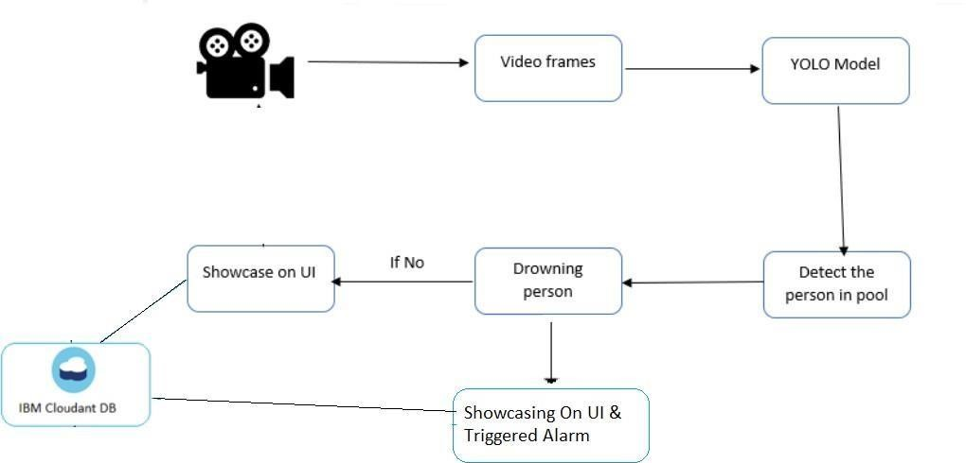

**6. PROJECT PLANNING & SCHEDULING**

##### 6.1 Sprint Planning & Estimation

**Project Tracker, Velocity & Burndown Chart:**

|  |  |  |  |  |  |  |
| --- | --- | --- | --- | --- | --- | --- |
| **Sprint** | **Total**  **Story**  **Points** | **Duration** | **Sprint Start Date** | **Sprint**  **End Date**  **(Planned)** | **Story Points**  **Completed**  **(as on**  **Planned End**  **Date)** | **Sprint**  **Release Date**  **(Actual)** |
| Sprint-1 | 8 | 6 Days | 24 Oct 2022 | 29 Oct 2022 | 6 | 29 Oct 2022 |
| Sprint-2 | 14 | 6 Days | 31 Oct 2022 | 05 Nov 2022 | 12 | 05 Nov 2022 |
| Sprint-3 | 16 | 6 Days | 07 Nov 2022 | 12 Nov 2022 | 11 | 12 Nov 2022 |
| Sprint-4 | 12 | 6 Days | 14 Nov 2022 | 19 Nov 2022 | 12 | 19 Nov 2022 |

**Velocity:**

Imagine we have a 10-day sprint duration, and the velocity of the team is 20 (points per sprint). Let’s calculate the team’s average velocity (AV) per iteration unit (story points per day) For Sprint-1 the Average Velocity (AV) is: AV = Sprint Duration / velocity = 8 / 6 = 1.3V For Sprint-2 the Average Velocity (AV) is: AV = Sprint Duration / velocity = 14 / 6 = 2.3V For Sprint-3 the Average

Velocity (AV) is: AV = Sprint Duration / velocity = 16 / 6 = 2.6V For Sprint-4 the Average Velocity (AV) is: AV = Sprint Duration / velocity = 12/ 6 = 2.0V

TOTAL TEAM AVERAGE VELOCITY = 2.08

**Burndown Chart:** A burn down chart is a graphical representation of work left to do versus time. It is often used in agile [software](https://www.visual-paradigm.com/scrum/what-is-agile-software-development/)

[development m](https://www.visual-paradigm.com/scrum/what-is-agile-software-development/)ethodologies such as [Scrum.](https://www.visual-paradigm.com/scrum/scrum-in-3-minutes/) However, burn down charts can be applied to any project containing measurable progress over time.

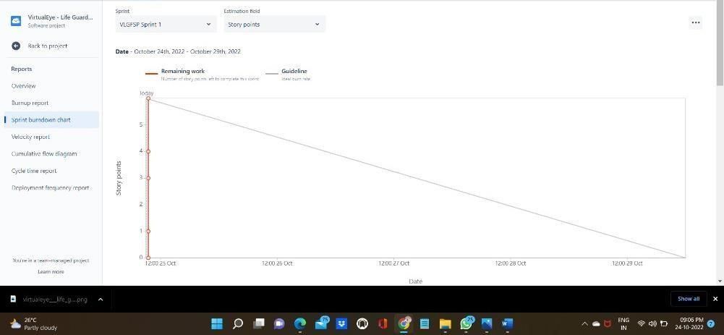

##### 9. RESULTS

###### 9.1 Performance Metrics

As soon as the tracking person is identified as drowning, the suggested technology alerts the lifeguard rescues. Determine if the target being monitored is above the water (green) or below it using a visual signal (red). Due to the fact that different boards move at different speeds, a red alarm and beep sound are produced when the swimmer is not detected by the system for more than a predetermined number of consecutive frames. In this

|  |
| --- |
| at 1.6GHz and 2GB of LPDDR3 RAM.   1. **ADVANTAGES & DISADVANTAGES**   The staff members tasked with monitoring the activities occurring in the pools offer vigilance to ensure swimmer protection at all facilities. There are several crucial elements with these controls. The major issue is how difficult it is to see the pool's bottom. LifeGuard is especially made to assist lifeguards in keeping an eye on swimmers. It provides an additional layer of security and effortlessly incorporates into rescue operations. To keep track of what transpired, the LifeGuard system can record all activities that take place in the pools and separate significant events from everyday occurrences. LifeGuard complies with all statutory standards for the protection of personal data because of its sophisticated image archiving technology.   1. **CONCLUSION**   Using a video surveillance system that can automatically identify drowning accidents in a swimming pool, we presented a method for robust person tracking and semantic event recognition in this study. In the current study, swimmers can be successfully spotted and tracked despite the large presence of water ripples thanks to an efficient backdrop detection that includes prior information using HSV colour space and contour recognition. The device has undergone testing in a variety of water simulation scenarios, including water reflection, lightning conditions, and false alarms. Our system had an average detection delay of 1.53 seconds, which is relatively short when   1. **FUTURE SCOPE**   The first virtual lifeguard for residential swimming pools in the world, MYLO, notifies owners when someone enters the water and when a swimmer seems to be in peril. The technology detects possible issues before they become fatal using above- and below-water cameras, real-time video, and artificial intelligence (AI) swimming experience. When someone in the water behaves in a way that suggests panic, the AI-powered technology sends wireless signals and activates the alarm. Only after the pool has been empty and still for more than five minutes, suggesting that nobody is utilizing it, are alerts concerning entries delivered. Alerts won't be sent out when a group of people is using the area and kids are entering   1. **APPENDIX** **GitHub & Project Demo Link**   GitHub link :https://github.com/IBM-EPBL/IBM-Project-3288-1658513136 |